

WFG NATIONAL TITLE INSURANCE COMPANY
ALTA 19-06 CONTIGUITY-MULITPLE PARCELS ENDORSEMENT

Attached to and made a part of policy number: ____________

The Company insures against loss or damage sustained by the Insured by reason of:

- the failure [of the____________ boundary line of Parcel A] of the Land to be contiguous to [the_______________ boundary line of Parcel B] or .

2. the presence of any gaps, strips, or gores separating any of the contiguous boundary lines described above.

This endorsement is issued as part of the policy. Except as it expressly states, it does not (i) modify any of the terms and provisions of the policy, (ii) modify any prior endorsements, (iii) extend the Date of Policy, or (iv) increase the Amount of Insurance. To the extent a provision of the policy or a previous endorsement is inconsistent with an express provision of this endorsement, this endorsement controls. Otherwise, this endorsement is subject to all of the terms and provisions of the policy and of any prior endorsements.

IN WITNESS WHEREOF the Company has caused its corporate name and seal to be hereunto affixed by its duly authorized officers on the __________day of _______, 20__.

Dated:
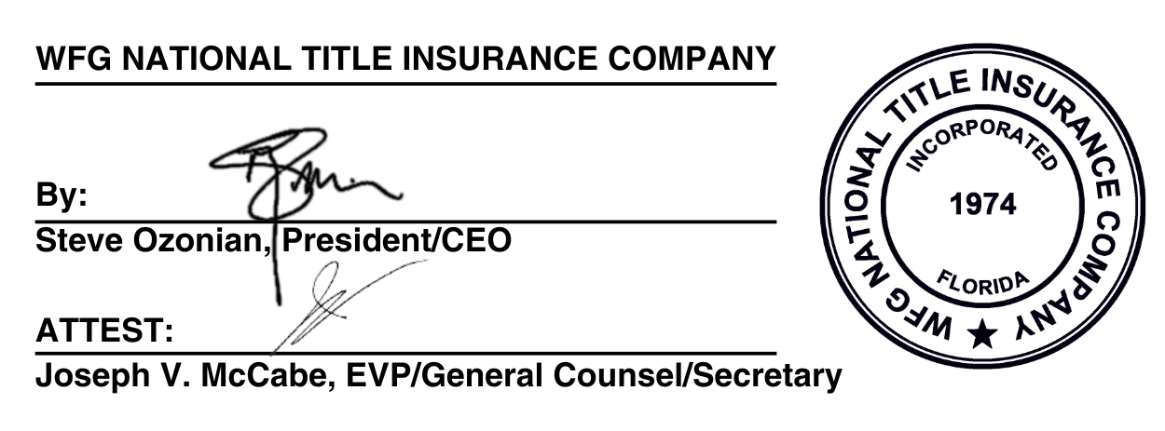
WFG NATIONAL TITLE INSURANCE COMPANY

By: _______________________________________
Authorized Signatory


Copyright 2021 American Land Title Association. All rights reserved.
The use of this Form (or any derivative thereof) is restricted to ALTA licensees and
ALTA members in good standing as of the date of use. All other uses are prohibited.
Reprinted under license from the American Land Title Association.

